What is Big data ?
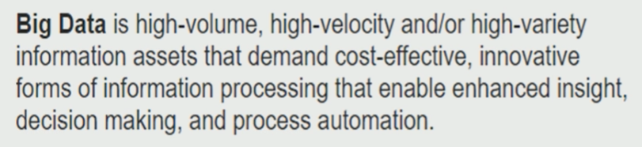

V-V-V :
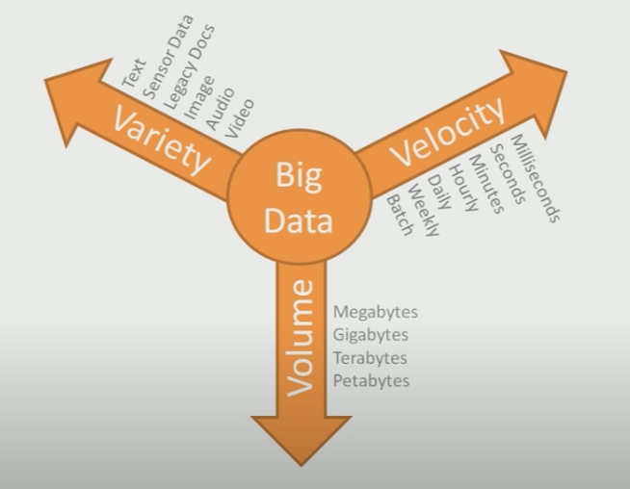

Hadoop 1.0.0 :
- A distributed file system
- A distributed programming framework (map reduce)
Hadoop 2.0.0 :
- A distributed file system (HDFS)
- A distributed programming framework (map reduce)
- YARN
Hadoop 3.0.0 alpha2 :
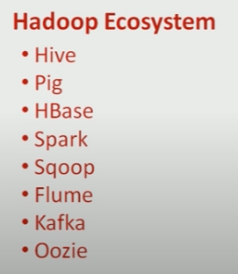
Hive, Spark and Kafka are the most widely adapted system from Hadoop.
Hadoop Tutorial - HDFS Features - YouTube

Resources :
Hadoop Tutorial - Introduction - YouTube

